- Write a CREATE TABLE statement for the CUSTOMER table with customer_id primary key, name, address, phone, and email columns
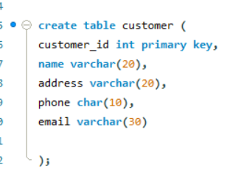

- Write a CREATE TABLE statement for the ORDER table that includes a foreign key referencing CUSTOMER customer_id.
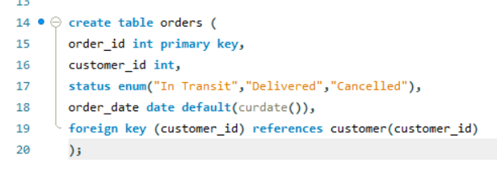

- Create the SHIPMENT table with shipment_id as primary key and route_id as a foreign key referencing ROUTE route_id.
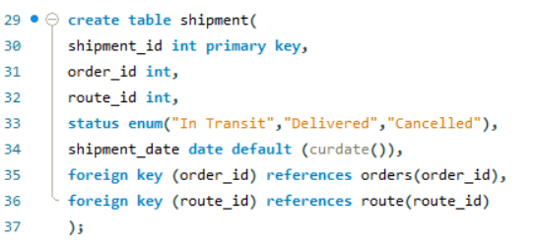

- Create the TRACKING table with tracking_id PK, shipment_id FK, location string, and timestamp date.
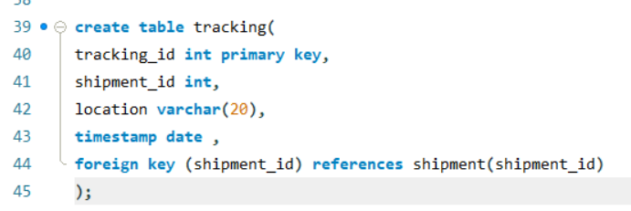

- Insert a new customer with name 'Asha Thapa', address 'Kathmandu', phone '9800000001', and email 'asha@mail.com' .
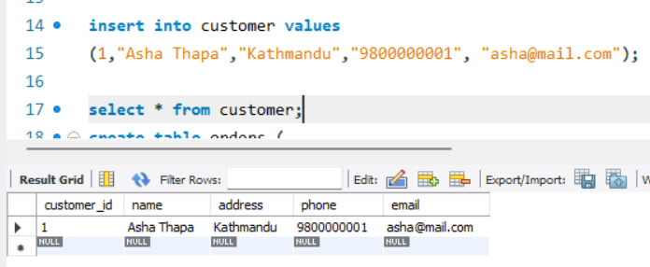

- Insert an order for customer_id=1, status='Pending', and today's date as order_date.
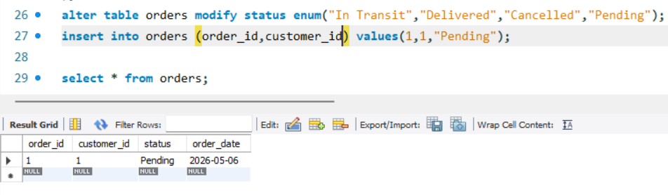

- Insert a ROUTE record with origin='Kathmandu', destination='Pokhara', distance=200.
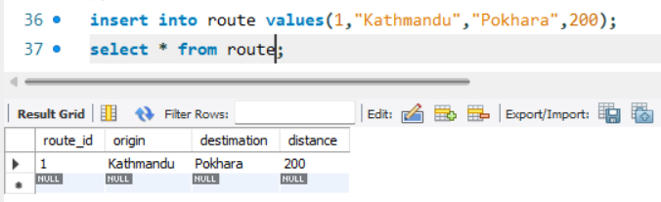

- Insert a SHIPMENT record that links order_id=3 with route_id=1, status='In Transit', and today's date.
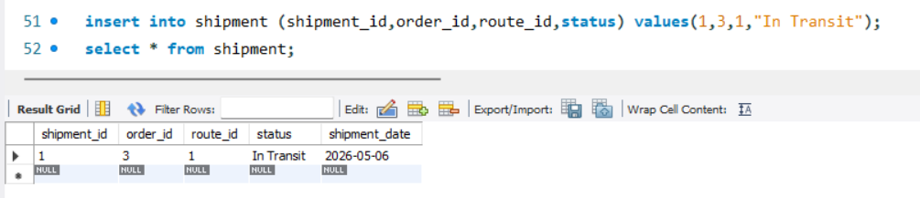
- Retrieve all columns for every customer in the CUSTOMER table.
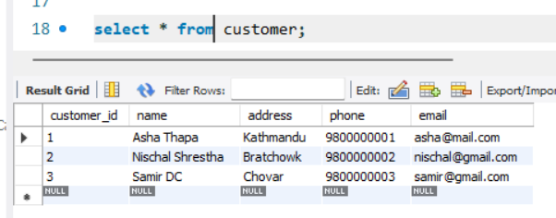

- Display the order_id, status, and order_date for all orders that have status 'Delivered'.
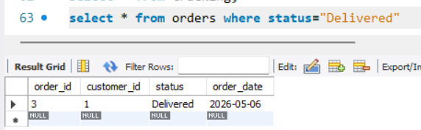

- List all shipments sorted by shipment_date in descending order.
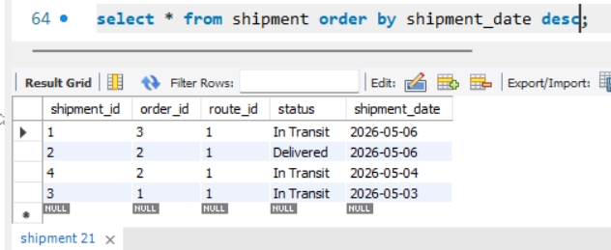

- Retrieve the top 5 heaviest parcels (by weight) from the PARCEL table.
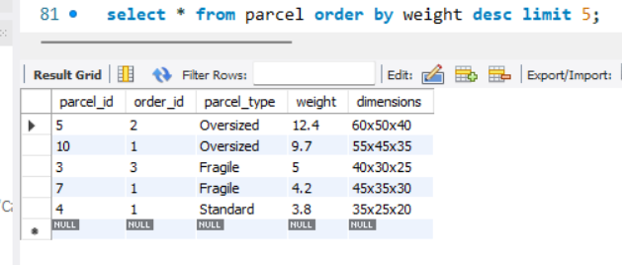

- Find all customers whose name starts with the letter 'A'.
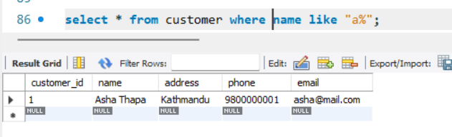
- Retrieve all customers whose email ends with '@gmail.com'.
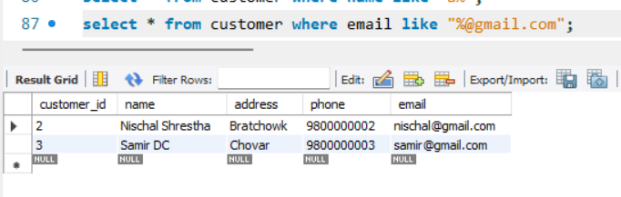
- Add a new column called 'loyalty_points' of type INT to the CUSTOMER table
16. Rename the column 'status' in the ORDER table to 'order_status'
17. Change the data type of the 'distance' column in ROUTE from INT to FLOAT
18. Delete all orders that have a status of 'Cancelled'
19. Update the status of order_id=5 to 'Shipped'
20. Increase the weight of all parcels of type 'box' by 0.5 k
21. Update the phone number for customer_id=3 to '9811223344'
22. Show all shipments along with the route origin and destination for each
23. List every order along with the customer's name and email who placed it
24. List customers who have never placed an order

